“Vehicle Service Booking & Tracking System”
A Project Report Submitted in the partial fulfillment of the requirements for the award of the degree of

BACHELOR OF TECHNOLOGY
In
DEPARTMENT OF COMPUTER SCIENCE AND INFORMATION TECHNOLOGY
By

ANUMOLA JHANSI PRIYA 2520090205
KEERTHI PRIYA ANDE 2520090177

Under the Esteemed Guidance of Dr.Khaja Shareef
Associate Professor

Department of Computer Science and Information Technology




K L (Deemed to be) University

DEPARTMENT OF COMPUTER SCIENCE AND INFORMATION TECHNOLOGY

Declaration

The Project Report entitled “Vehicle Service Booking & Tracking System” is a record of bonafide work of ANUMOLA JHANSI PRIYA – 2520090205, KEERTHI PRIY ANDE - 2520090177 submitted in partial fulfillment of the requirements of the course DATABASE SYSTEMS ENGINEERING AND DISTRIBUTED BACKEND DEVELOPMENT (25CS1302E), Section 12, Team 2, during 2026–2027, Trimester 4, at KLH University. The results embodied in this report have not been copied from any other student, department, or institution.

ANUMOLA JHANSI PRIYA – 2520090205
KEERTHI PRIYA ANDE-2520090177

K L (Deemed to be) University

DEPARTMENT OF COMPUTER SCIENCE AND INFORMATION TECHNOLOGY

CERTIFICATE

This is to certify that the project report entitled “Vehicle Service Booking & Tracking System” is a bonafide work done and submitted by ANUMOLA JHANSI PRIYA – 2520090205, KEERTHI PRIYA ANDE – 2520090177 in partial fulfillment of the requirements of the course DATABASE SYSTEMS ENGINEERING AND DISTRIBUTED BACKEND DEVELOPMENT (25CS1302E), Section 12, Team 2, at KLH University
during 2026–2027, Trimester 4.

Signature of the Guide

Signature of the Course Coordinator Signature of the HOD

ACKNOWLEDGEMENT
The success in this project would not have been possible but for the timely help and guidance rendered by many people. Our wish to express my sincere thanks to all those who has assisted us in one way or the other for the completion of my project.

Our greatest appreciation to my Course Coordinator Dr, and my guide Khaja Shareef, Department of Computer Science and Information Technology which cannot be expressed in words for his/her tremendous support, encouragement and guidance for this project.

We express our gratitude to Dr. Khaja Shareef, Head of the Department for Computer Science and Information Technology for providing us with adequate facilities, ways and means by which we are able to complete this project-based Lab.

We thank all the members of teaching and non-teaching staff members, and also who have assisted me directly or indirectly for successful completion of this project. Finally, I sincerely thank my parents, friends and classmates for their kind help and cooperation during my work.

ANUMOLA JHANSI PRIYA – 2520090205

KEERTHI PRIYA ANDE-2520090177

Abstract

The Vehicle Service Booking and Tracking System is a web-based application developed to simplify the process of booking, managing, and tracking vehicle maintenance services. The system allows customers to schedule service appointments online by selecting the required service from a predefined catalog. It eliminates the traditional manual booking process and provides a convenient platform for both customers and service center administrators. The application also enables customers to view their service history, receive reminders for upcoming maintenance, and access digital invoices.
The system incorporates a Job Card and Technician Allocation module that automatically generates service job cards and assigns technicians based on their availability and specialization. A Live Status Tracking feature keeps customers informed about the progress of their vehicles through real-time notifications. The system also maintains a Spare Parts Inventory to monitor the availability of vehicle components required during servicing. This reduces delays and improves service efficiency.
The application is developed using React.js for the front-end user interface, Node.js and Express.js for server-side processing, and MySQL for database management. Firebase Cloud Messaging (FCM) is integrated to provide instant status updates and notifications, while Razorpay is used to support secure online payments. The proposed system improves communication between customers and service centers, enhances operational efficiency and user-friendly vehicle service management solution.

Index
S.No. | Chapters | Topics | Page No.
 |  | Acknowledgement
 |  | Abstract
1 | Introduction | - Background of the Project  - Problem Statement  - Scope of the Project  - Objectives  - Importance of the Application  - Target Users / Audience | 5
2 | System Requirements | - Hardware Requirements  - Software Requirements  - Development Tools and Frameworks | 8
3 | Technology Stack | - Frontend  - Backend  - Database  - Version Control  - Authentication and Security Libraries | 9
4 | System Architecture | - High-Level Architecture Diagram  - Description of Each Layer  - Deployment Architecture | 10
5 | Design | - Database Design Principles  - ER Diagram / Database Schema  - Design Decisions and Assumptions | 11
6 | Implementation | - Module-wise Implementation  - Front-end Logic  - API Integration  - Authentication and Authorization | 12
7 | Features | - List of Main Features  - How Each Feature Works | 14
8 | Testing | - Postman API Testing  - Integration Testing  - Tools Used for Testing  - Test Cases and Results | 15
9 | Deployment | - Steps to Deploy  - Environment Configuration  - Hosting of Frontend and Backend | 16
10 | Challenges & Limitations | - Issues Faced During Development  - Solutions Applied  - Current Limitations or Known Bugs | 17

S.No. | Chapters | Topics | Page No.
11 | Future Enhancements | - Planned Features  - Possible Integrations or Optimizations | 18
12 | Conclusion | - Summary of the Project  - What Was Achieved  - Skills Learned | 19
13 | References | – Documentation, tools, and resources used | 20
14 | Appendices | - Sample Code Snippets  - Installation / Setup Instructions  - Default Login Credentials  - API Reference Summary  - Screenshots (to be added by the student) | 21

CHAPTER -1 INTRODUCTION

Background of the Project
Vehicle maintenance is an important part of ensuring vehicle safety, reliability, and performance. Traditionally, customers often depend on phone calls, physical visits, or manual records to schedule and track vehicle servicing.
The Vehicle Service Management System is a web-based application developed to simplify the vehicle servicing process. It provides customers with a digital platform where they can register, log in, book vehicle services, view bookings, track service progress, view service history, make or view payment information, receive notifications, view technician information, and provide feedback.
The system uses a React-based frontend, Node.js and Express.js backend, and MySQL database to manage application data.

Problem Statement
Traditional vehicle service management can involve several difficulties:
- Manual booking and record maintenance.
- Difficulty in tracking service progress.
- Lack of centralized customer and vehicle information.
- Difficulty maintaining service history.
- Manual communication between customers and service centers.
- Limited visibility of payment and service information.
Therefore, a centralized web application is required to make vehicle service management easier, organized, and accessible.

Scope of the Project
- User registration and login.
- Customer profile management.
- Vehicle service booking.
- Selection of vehicle type and service type.
- Viewing previous and current bookings.
- Service progress tracking.
- Service history management.
- Payment information.
- Notifications.
- Technician information.
- Customer feedback.
- MySQL-based data storage.
- REST API communication between frontend and backend.
The system is primarily designed for customers and vehicle service centers.

Objectives
- To develop a user-friendly vehicle service management application.
- To provide secure user registration and login.
- To allow customers to book vehicle services online.
- To provide service tracking functionality.
- To maintain vehicle service records and history.
- To provide payment-related information.
- To improve communication through notifications.
- To allow customers to provide service feedback.
- To store application data in a centralized MySQL database.

Importance of the Application
The application provides a centralized platform for managing vehicle services. It reduces dependency on manual records and makes service information easier to access.
Customers can conveniently manage their bookings and follow the progress of their vehicle service. The system also provides structured information about services, payments, technicians, and service history.

Target Users / Audience
The primary users are:
Customers – book services, track vehicles, view payments, history, and provide feedback.
Service Staff / Technicians – service-related information can be provided through the system.
Vehicle Service Centers – can use the system as a foundation for managing customer service operations.

CHAPTER 2: SYSTEM REQUIREMENTS

Hardware Requirements
- Processor: Intel Core i3 or equivalent
- RAM: 4 GB or above
- Storage: 10 GB available space
- Display: 1366 × 768 or higher

Internet connection for package installation and development resources

Software Requirements
- Operating System: Windows / Linux / macOS
- Node.js
- npm
- MySQL Server
- MySQL Workbench or similar database tool
- Visual Studio Code
- Modern web browser
- Git / GitHub

Development Tools and Frameworks
- React.js – frontend development
- Node.js – backend runtime
- Express.js – REST API development
- MySQL – database management
- bcryptjs – password hashing
- Visual Studio Code – development environment
- Git/GitHub – version control
- Postman/ThunderClient–APItesting

CHAPTER 3: TECHNOLOGY STACK

Frontend

The frontend of the Vehicle Service Management System is developed using React.js, which is a JavaScript library used for building interactive and component-based user interfaces. React allows the application to be divided into reusable components such as Login, Register, Dashboard, Booking Form, My Bookings, Track Service, Payment, Notifications, Technician, Service Feedback, Profile, and Service History. These components make the application easier to organize, maintain, and update. The frontend communicates with the backend through HTTP requests to access authentication and booking-related services.

Backend

The backend of the system is developed using Node.js and Express.js. Node.js provides the runtime environment for executing JavaScript on the server, while Express.js is used to create REST API endpoints and handle HTTP requests. The backend receives requests from the React frontend, processes the required operations, communicates with the MySQL database, and sends appropriate responses back to the frontend. The authentication and booking operations are handled through separate API routes and controller functions.

Database

The system uses MySQL as its relational database management system. MySQL is responsible for storing important information such as registered user details and vehicle service booking information. The user table stores details such as name, email, phone number, and encrypted password. The booking information contains details such as vehicle number, vehicle type, service type, booking date, user ID, and service status. Relationships between users and bookings allow the system to associate each service booking with the corresponding user.

Version Control

Git can be used as the version control system for the project to manage changes made during development. Version control helps maintain different versions of the source code and makes it easier to identify or restore previous changes when required. The project can also be stored in a GitHub repository to maintain a remote copy of the source code and support future collaborative development.

Authentication and Security Libraries

The system uses bcryptjs for password security. During user registration, the password entered by the user is converted into a hashed value before being stored in the database. During login, the entered password is compared with the stored hashed password using bcrypt. This prevents the application from storing passwords directly in plain text. The current implementation provides basic authentication through registration and login, while additional token-based authentication and authorization can be added as a future enhancement.

CHAPTER 4: SYSTEM ARCHITECTURE

High-Level Architecture Diagram

The Vehicle Service Management System follows a three-layer architecture consisting of the frontend, backend, and database. The user interacts with the React frontend through a web browser. The frontend sends requests to the Express.js backend using REST APIs. The backend processes these requests and communicates with the MySQL database to store or retrieve information. The processed response is then returned to the frontend and displayed to the user.

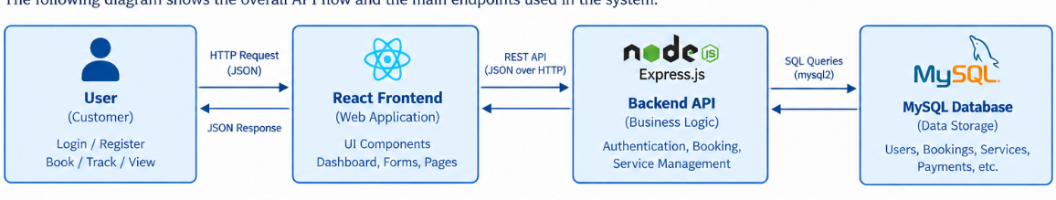

Description of Each Layer
The presentation layer is implemented using React.js and is responsible for displaying the application's user interface. It contains pages and components through which users can register, log in, book services, view bookings, track service progress, view service history, and access other system features.The application layer is implemented using Node.js and Express.js. It contains the business logic of the application and provides API endpoints for operations such as user registration, login, and booking management. This layer also communicates with the database and returns the required information to the frontend.The data layer consists of the MySQL database. It stores persistent information related to users and vehicle service bookings. SQL queries are executed by the backend to insert, retrieve, and process the required data.

Deployment Architecture
During development, the frontend and backend run as separate local services. The React development server runs on the local machine, while the Node.js and Express backend runs on another local port. The backend connects to the locally configured MySQL database. In the current development setup, the frontend is accessed through the React development server, commonly using port 5173, while the backend API runs on port 5000.
For production deployment, the frontend, backend, and database can be hosted on suitable cloud or server infrastructure. Environment variables should be used to store database credentials and other configuration values securely.

CHAPTER 5: DESIGN

Database Design Principles
The database is designed to store user and booking information in a structured manner. A relational database approach is used so that information can be organized into tables and connected using relationships. Each user is identified using a unique user ID, while each booking has its own booking ID. The user ID is used to associate bookings with the users who created them. The design aims to reduce unnecessary duplication of data and maintain consistency between related records.The database design also separates authentication information from booking information. This makes it easier to retrieve a user's service bookings without repeatedly storing the user's personal details in every booking record.

ER Diagram / Database Schema
The database consists of seven related tables, shown in Figure 5.1.
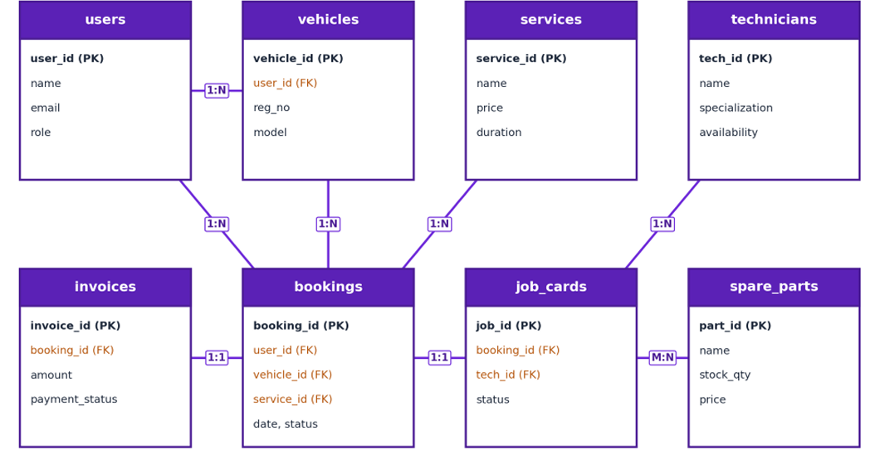
The Users entity contains information such as user ID, name, email, phone number, and password. The Bookings entity contains booking ID, user ID, vehicle number, vehicle type, service type, booking date, and service status.
The user_id in the booking record connects the booking with the corresponding user. This relationship allows the application to retrieve and display bookings associated with a particular user.

Design Decisions and Assumptions
The system was designed with simplicity and usability in mind. React components are used to divide the frontend into separate functional sections, while Express routes and controllers are used to organize backend operations. MySQL was selected because the application contains structured and relational data. Password hashing was implemented using bcryptjs to improve security.
The system assumes that users register before accessing their service-related information. Each booking is associated with a user ID so that the application can display the relevant service records. The current implementation also uses a local storage entry for maintaining the active booking information on the frontend.

CHAPTER 6: IMPLEMENTATION

Module-wise Implementation
The system is divided into several modules to provide different vehicle service management functions. The Authentication Module handles user registration and login. The Dashboard Module provides the main navigation interface after successful login. The Booking Module allows users to enter vehicle and service details and create a service booking.
The My Bookings Module displays the user's booking records, while the Track Service Module displays the current progress of a service through different stages such as Booking Confirmed, Vehicle Received, Service in Progress, Quality Check, and Ready for Pickup. The Service History Module allows users to view previous service records. Other modules such as Payment, Notifications, Technician, Service Feedback, and Profile provide additional sections for extending the functionality of the system.

Front-end Logic
The frontend uses React state management to control the application interface and user interactions. The Dashboard maintains the currently selected page and displays the corresponding component. Forms such as Login, Register, and Booking Form use state variables to store user input.
When a user submits a form, the frontend sends an HTTP request to the appropriate backend API. Based on the response received from the server, the interface displays success or error messages. The frontend also uses browser local storage for maintaining active booking information required by the current application flow.

API Integration
The React frontend communicates with the Node.js backend through REST API endpoints. During registration, the frontend sends user information to the registration endpoint. During login, the entered email and password are sent to the login endpoint for verification.The booking module sends vehicle and service details to the booking API. The backend processes the request and stores the booking information in MySQL. The frontend can also request booking records from the backend and display them in pages such as My Bookings and Service History.

Authentication and Authorization
The authentication process begins when a new user registers with their name, email, phone number, and password. The backend uses bcryptjs to hash the password before storing it in the database. During login, the backend retrieves the user based on the provided email and compares the entered password with the stored hash.
After successful authentication, the backend returns the user's basic information to the frontend. The React application then stores the logged-in user information in its application state and displays the Dashboard. The current implementation provides authentication but does not yet implement persistent token-based sessions or detailed role-based authorization.

CHAPTER 7: FEATURES

List of Main Features
The Vehicle Service Management System provides several features to make vehicle servicing easier to manage. Users can create an account and log into the application securely. After login, they can access a dashboard containing different service management options.
The system allows users to book vehicle services by entering their vehicle number, vehicle type, service type, and preferred booking date. Users can view their bookings, track the progress of a service, and view their service history. The system also provides separate sections for payments, notifications, technician information, feedback, and profile management, providing a foundation for a complete vehicle service management platform.

How Each Feature Works

The Registration and Login feature allows users to create accounts and authenticate themselves. The Book Service feature collects vehicle and service details and sends them to the backend for storage.

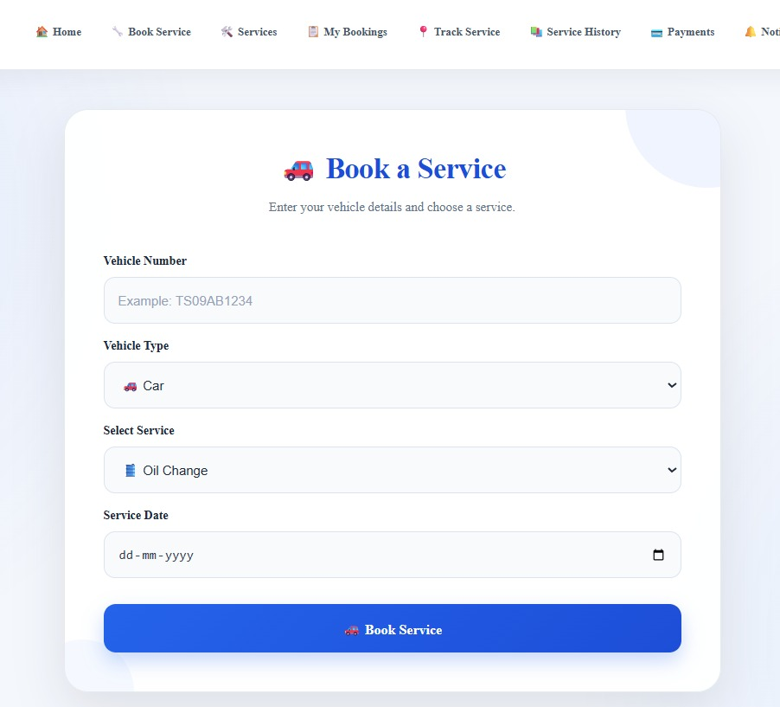

The My Bookings feature retrieves booking information and displays it to the user. The Track Service feature represents the progress of a service through multiple stages. The system also calculates an estimated service amount and GST for supported services.

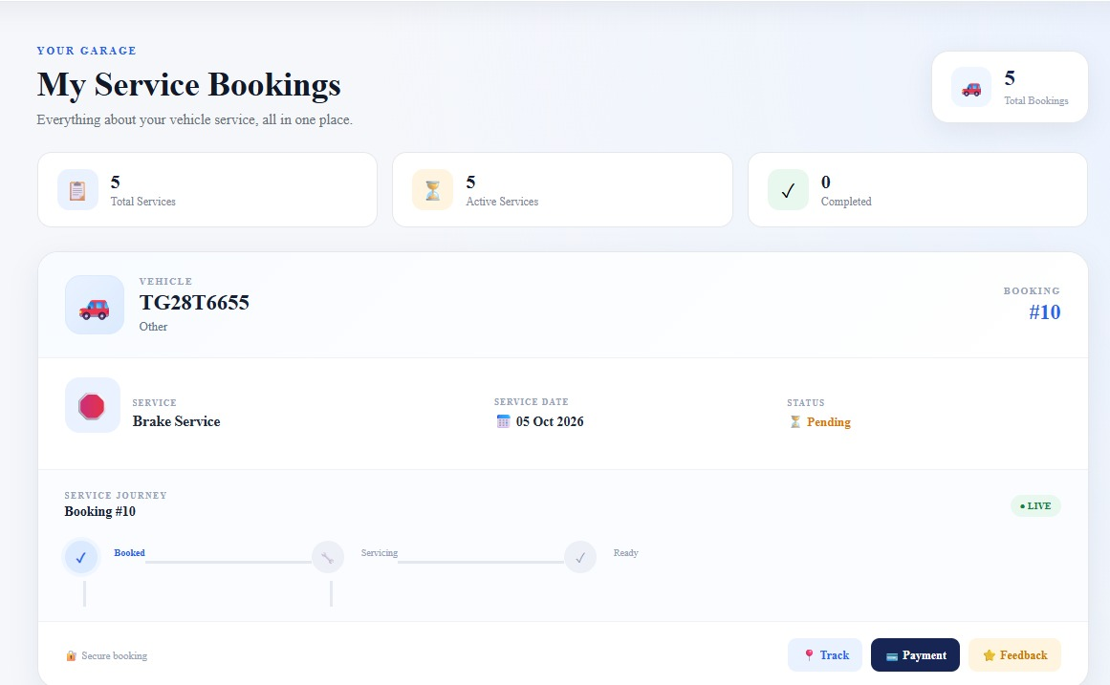

The Service History feature retrieves the user's previous booking records and displays information such as service type, vehicle, date, technician information, payment details, and estimated amount. The Payment, Feedback, Notifications, and Technician sections provide additional functionality and can be further connected to backend services as the system is expanded.

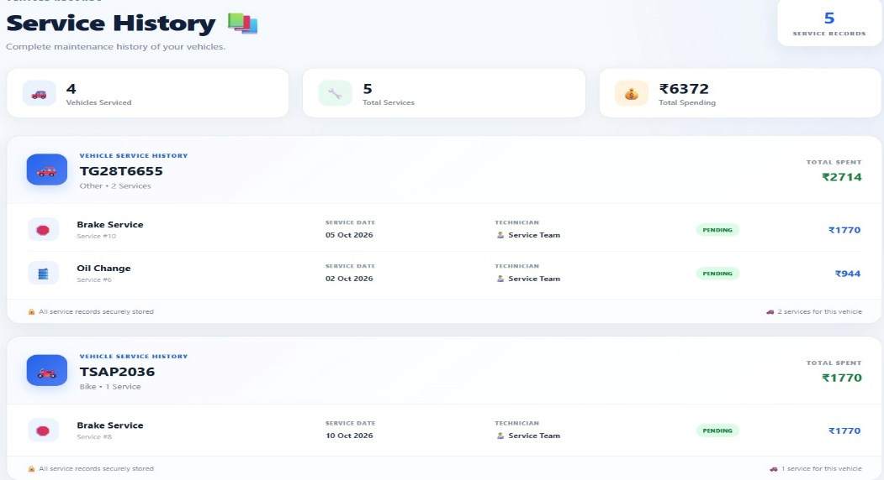

CHAPTER 8: TESTING

Postman API Testing
Postman can be used to test the REST APIs independently from the React frontend. The registration API can be tested by sending user information in JSON format and checking whether the server successfully creates a new user. Similarly, the login API can be tested with valid and invalid credentials to verify the authentication process. The booking API can be tested by sending vehicle and service information to the booking endpoint. The GET bookings endpoint can then be used to verify whether the booking information is returned correctly from the database.

Integration Testing
Integration testing is used to verify communication between the frontend, backend, and database. For example, when a user submits the booking form, the React frontend sends the booking information to the Express backend. The backend then stores the information in MySQL and returns a response. The frontend displays the result to the user. This type of testing ensures that the individual components work together correctly rather than functioning only as separate modules.

Tools Used for Testing

The major tools that can be used for testing the system include Postman for API testing, the web browser for frontend testing, and MySQL for verifying database records. Browser developer tools can also be used to inspect network requests, console errors, and frontend behaviour.

Test Cases and Results
The system can be tested using different functional test cases. A valid registration should create a new user account, while invalid or incomplete registration data should produce an appropriate error. Valid login credentials should allow access to the Dashboard, while incorrect credentials should display an authentication error.
Similarly, submitting a valid service booking should create a booking record in the database. The booking should then be visible in the appropriate booking and tracking sections. Service history should display records associated with the logged-in user's account.
Note: For your final report, you should mark the actual result as Pass/Fail based on the tests you personally executed rather than claiming tests were completed if you have not run them yet.

CHAPTER 9: DEPLOYMENT

Steps to Deploy
The application is deployed locally for development and demonstration as follows:
    - Load the schema and seed data: mysql -u root -p < database/schema.sql, then ... < database/seed.sql
    - Start the backend: cd backend, node server.js (listens on port 5000)
    - Start the frontend: cd frontend, npm install, npm run dev (listens on port 5173)
    - Open http://localhost:5173 in a browser and log in with a seeded account

Environment Configuration
All server configuration is kept in a single .env file (never committed to version control), covering the database connection (host, port, user, password, database name), the JWT signing secret and token expiry, the port the server listens on, and the frontend's URL for CORS. A .env.example template with placeholder values is committed instead, so the required variables are documented without exposing any real credentials.

Hosting of Frontend and Backend
For this submission, both the frontend and backend run as local Node.js processes and the database runs as a local MySQL instance, which is appropriate for development and in-class demonstration. Vite's development proxy forwards frontend API calls to the backend, avoiding any cross-origin configuration during development. A production deployment was not required for this course submission; Chapter 11 outlines how the same codebase could be adapted to a hosted environment.

CHAPTER 10: CHALLENGES & LIMITATIONS

Issues Faced During Development
- Connecting React frontend with the Express backend.
- Connecting backend APIs with MySQL.
- Maintaining user-specific booking information.
- Designing multiple dashboard modules consistently.
- Handling API errors and unavailable backend connections.
- Maintaining responsive layouts across different screen sizes.

Solutions Applied
- Used REST APIs for frontend-backend communication.
- Used MySQL queries through the backend.
- Used user_id to associate bookings with users.
- Added frontend validation for required fields.
- Added backend validation for required booking fields.
- Added error messages for failed API requests.
- Used reusable React components.

Organized styling into separate CSS files.Current Limitations or Known Bugs
- Full online payment gateway integration is not currently implemented.
- Advanced role-based admin authorization can be added.
- Production hosting configuration is not part of the current local setup.
- Some service information is currently represented using application-level data rather than a fully dynamic service-management backend.
- Real-time technician location tracking is not implemented.

CHAPTER 11: FUTURE ENHANCEMENTS

Planned Features
- Online payment gateway.
- Admin dashboard.
- Technician login.
- Customer service reminders.
- SMS and email notifications.
- Real-time service status updates.
- Vehicle maintenance reminders.
- Invoice generation.
- Downloadable service reports.

Advanced service history.Possible Integrations or Optimizations
The system can be enhanced by integrating:
- Payment gateway APIs.
- SMS services.
- Email notification services.
- Google Maps/location services.
- Cloud database hosting.
- Mobile application.
- AI-based maintenance recommendations.
The backend can also be optimized using better database indexing, API validation, authentication
tokens, caching, and structured error handling.

CHAPTER 12: CONCLUSION

Summary of the Project
The Vehicle Service Management System is a web-based application designed to simplify and organize vehicle servicing activities.
The system provides customers with a centralized platform for registration, login, service booking, service tracking, payments, notifications, technician information, feedback, profiles, and service history.

What Was Achieved

The Vehicle Service Management System was successfully developed as a web-based application to simplify and organize vehicle service management activities. The system provides user registration and login functionality, service booking, booking management, service tracking, service history, and other supporting modules such as payment, notifications, technician information, feedback, and profile management. The frontend was developed using React.js, while Node.js and Express.js were used for backend API development and MySQL was used for data storage. Passwords are protected using bcryptjs hashing. Through this project, a functional connection between the frontend, backend, and database was established, providing a structured platform for managing vehicle service-related information.

Skills Learned

During the development of this project, several technical and practical skills were gained. The project provided experience in developing user interfaces using React.js, managing component state, handling forms, and integrating frontend components with REST APIs. Backend development skills were improved through the use of Node.js and Express.js for creating API endpoints and processing requests. The project also provided practical knowledge of MySQL database design, SQL queries, and connecting a backend application with a database. In addition, experience was gained in implementing password hashing using bcryptjs, debugging application errors, testing APIs using tools such as Postman, organizing project files, and understanding the overall workflow of a full-stack web application.

CHAPTER 13: REFERENCES
    - React — Official Documentation, https://react.dev
    - Vite — Official Documentation, https://vitejs.dev
    - Node.js — Official Documentation, https://nodejs.org/en/docs
    - Express.js — Official Documentation, https://expressjs.com
    - MySQL 8.0 Reference Manual, https://dev.mysql.com/doc/refman/8.0/en/
    - mysql2 (Node.js MySQL driver) — npm documentation, https://www.npmjs.com/package/mysql2
    - jsonwebtoken — npm documentation, https://www.npmjs.com/package/jsonwebtoken
    - bcrypt — npm documentation, https://www.npmjs.com/package/bcrypt
    - Postman Learning Center, https://learning.postman.com
    - MDN Web Docs — JavaScript and Web APIs reference, https://developer.mozilla.org

CHAPTER 14: APPENDICES

Appendix A: Sample Code Snippet
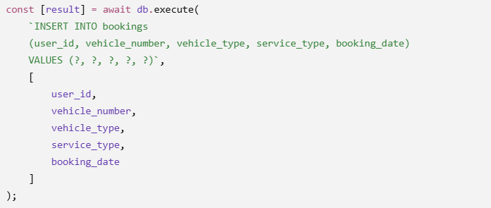

Appendix B: Installation and Setup Instructions
- mysql -u root -p < database/schema.sql
- mysql -u root -p < database/seed.sql
- cd backend && node server.js(backend, port 5000)
- cd frontend && npm install && npm run dev (frontend, port 5173)
- Open http://localhost:5173 in a browser

Appendix C: Default Login Credentials

Role | Email
users | jhansi@gmail.com
users | keerthi@gmail.com
users (others) | harish@gmail.com,vishal@gmail.com

Appendix D: API Reference Summary
The Vehicle Service Management System uses REST APIs to connect the React frontend with the Node.js and Express.js backend. The APIs handle user authentication and vehicle service booking operations. The main endpoints currently implemented in the system are summarized below.
Resource | Endpoints
Auth | POST /api/auth/login
Registrations | POST /api/auth/register
Bookings | POST /api/bookings, GET /api/bookings

Appendix E: Screenshots
The following pages are left for the student to complete with actual screenshots taken from the running application before submission. Suggested screenshots, in order:
- Login Page
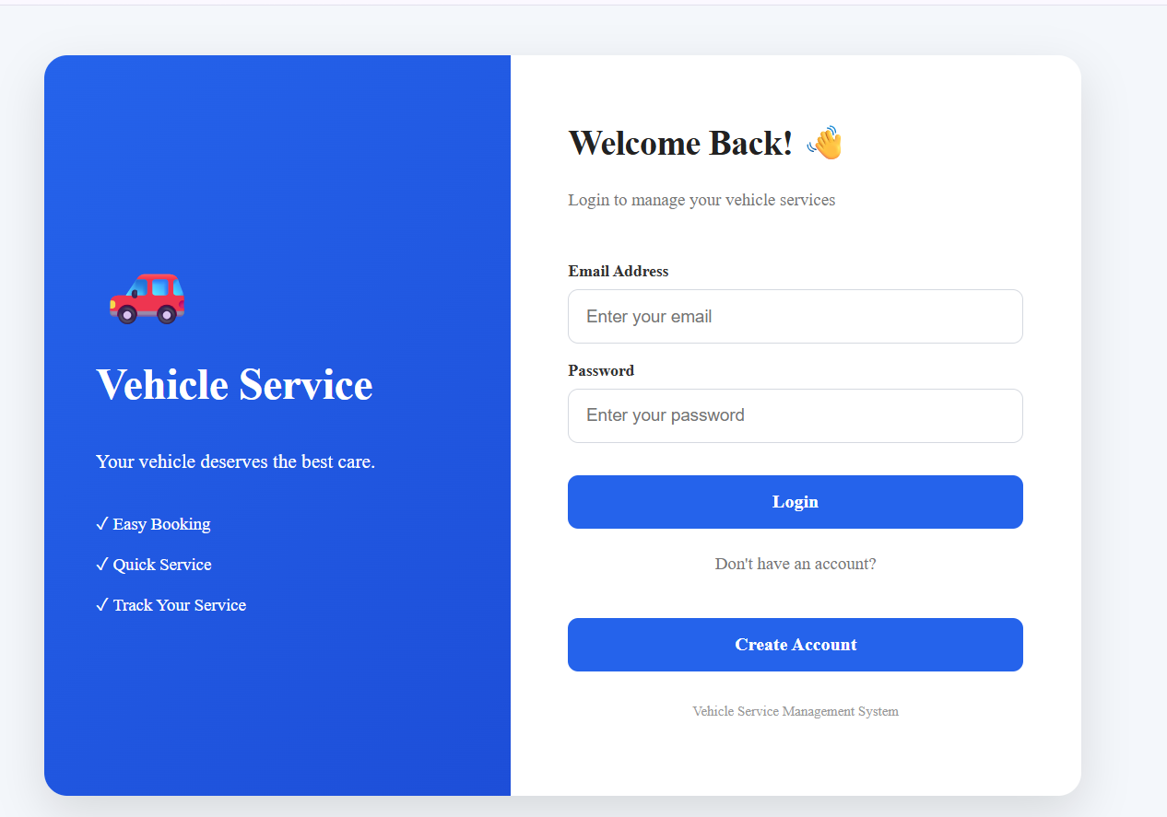
- Create Account / Sign Up Page

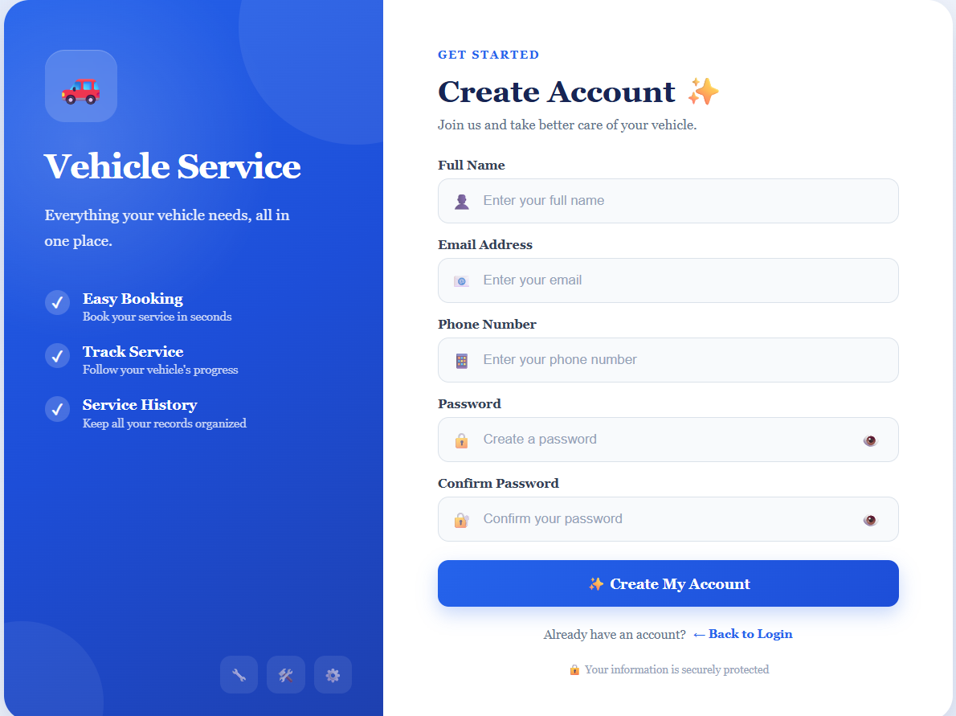

- Dashboard / Home Page

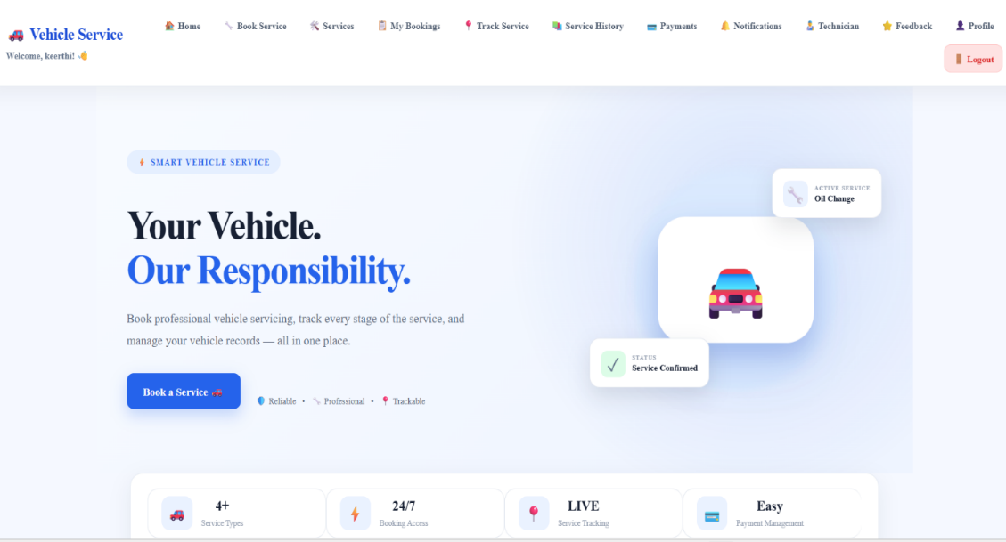

- Book Service Page
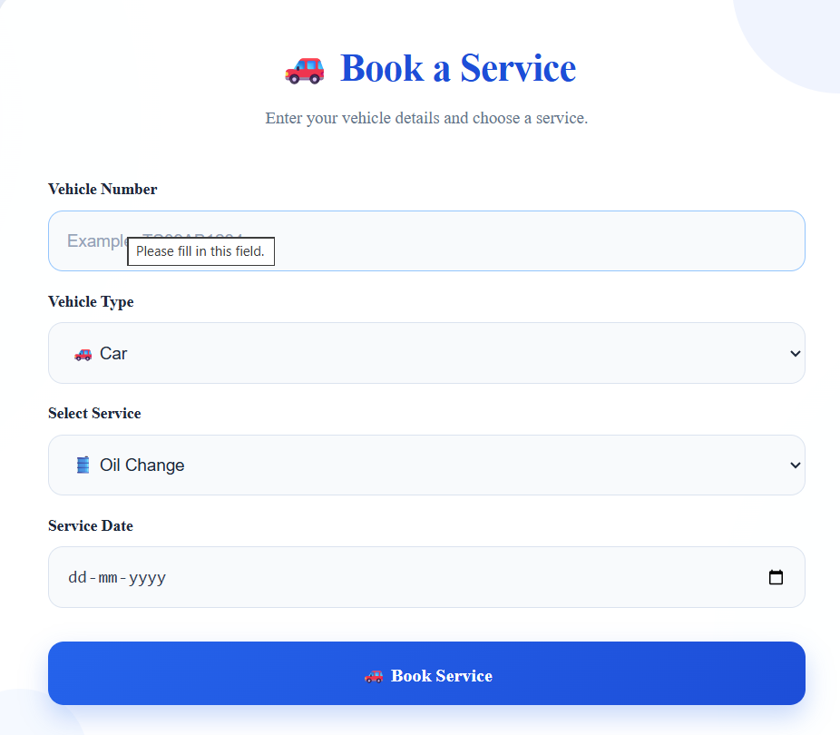

- My Bookings Page
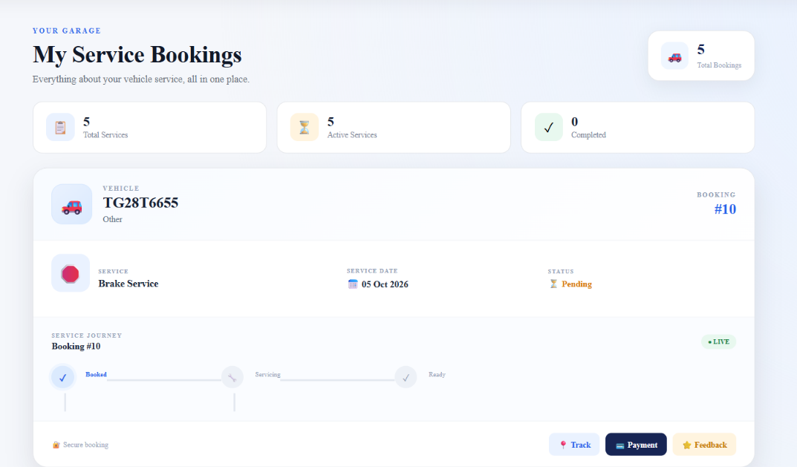
- Track Service Page
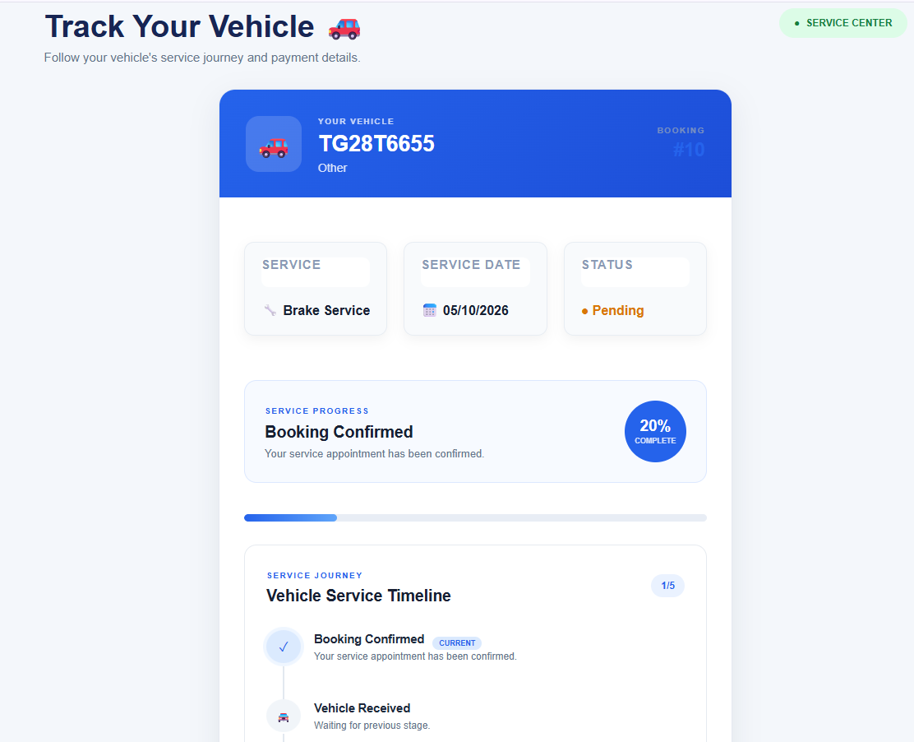

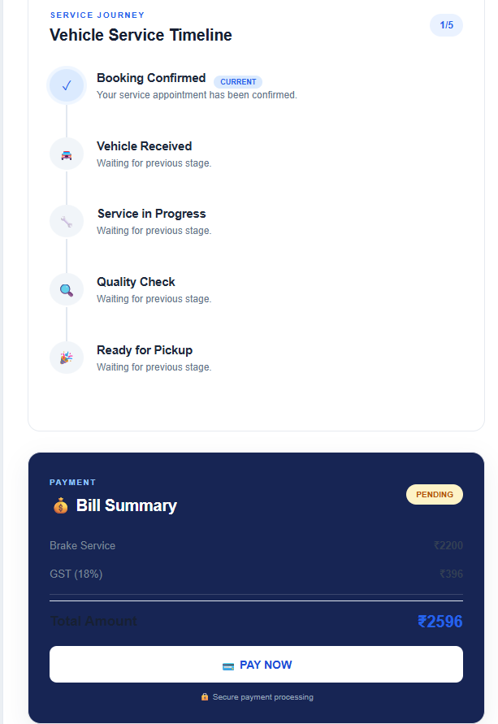

7. Service History
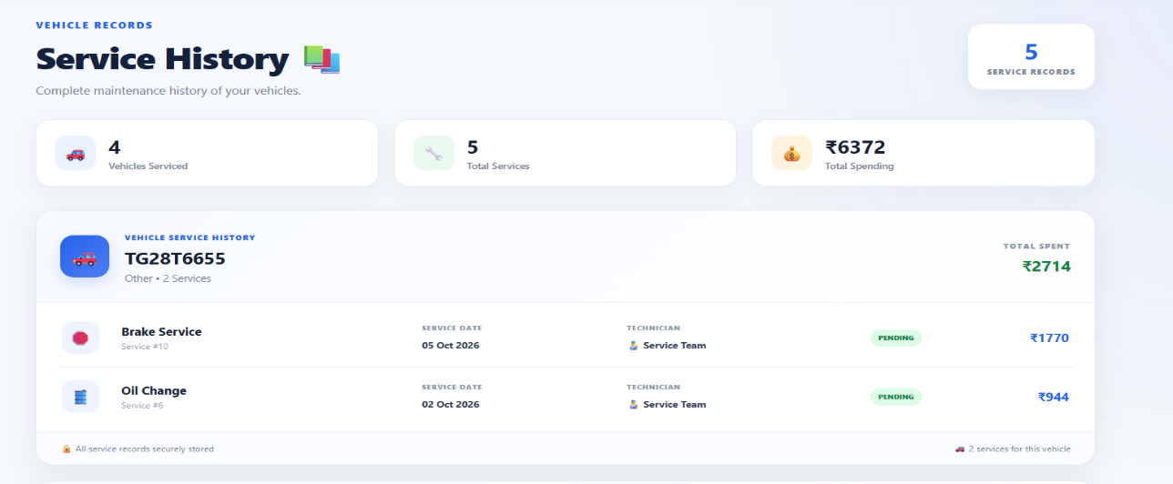

8.Payment Page
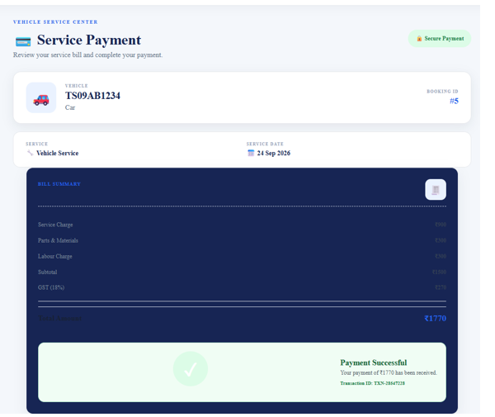

- Notifications Page
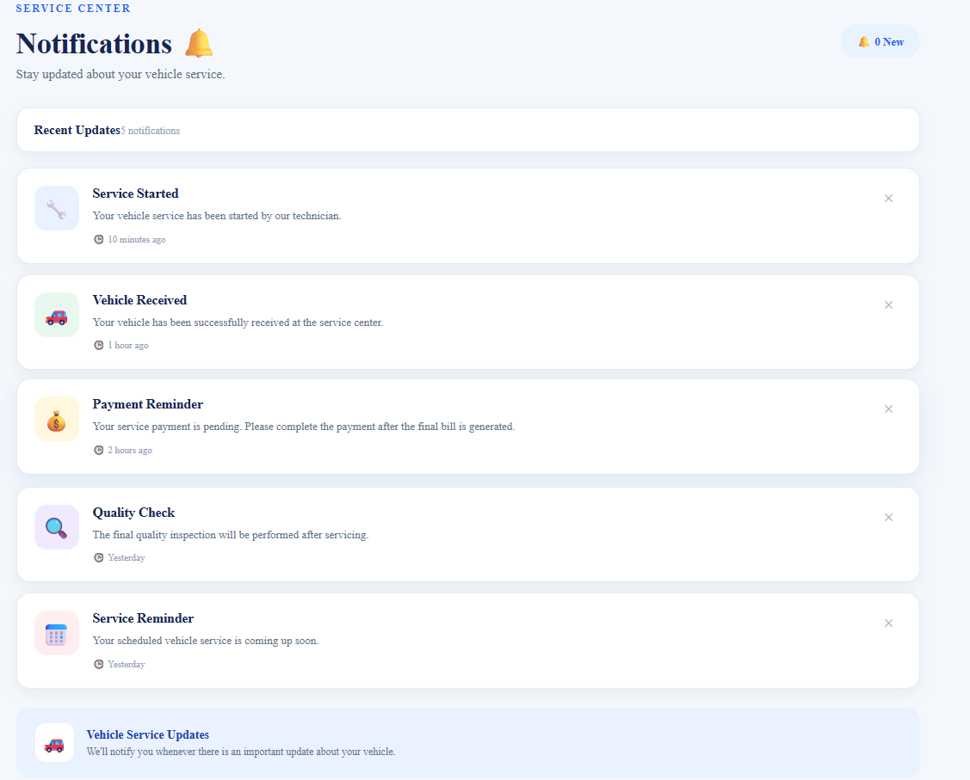

- Technician Page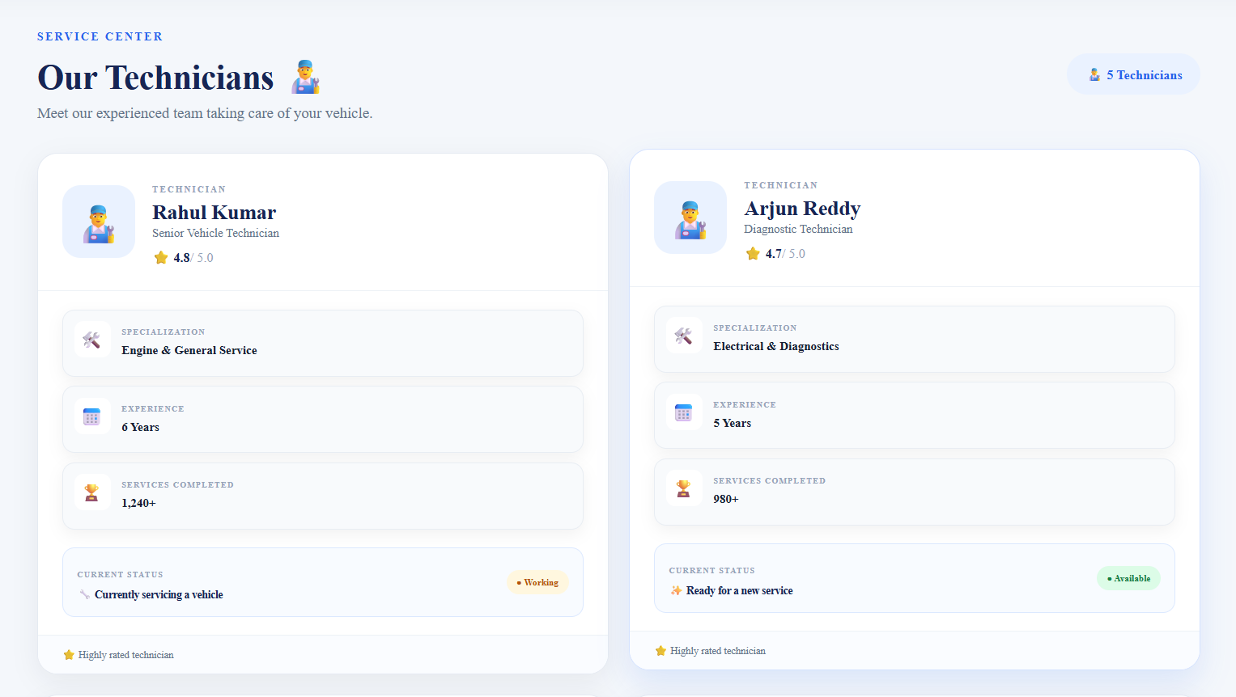

- Service Feedback Page 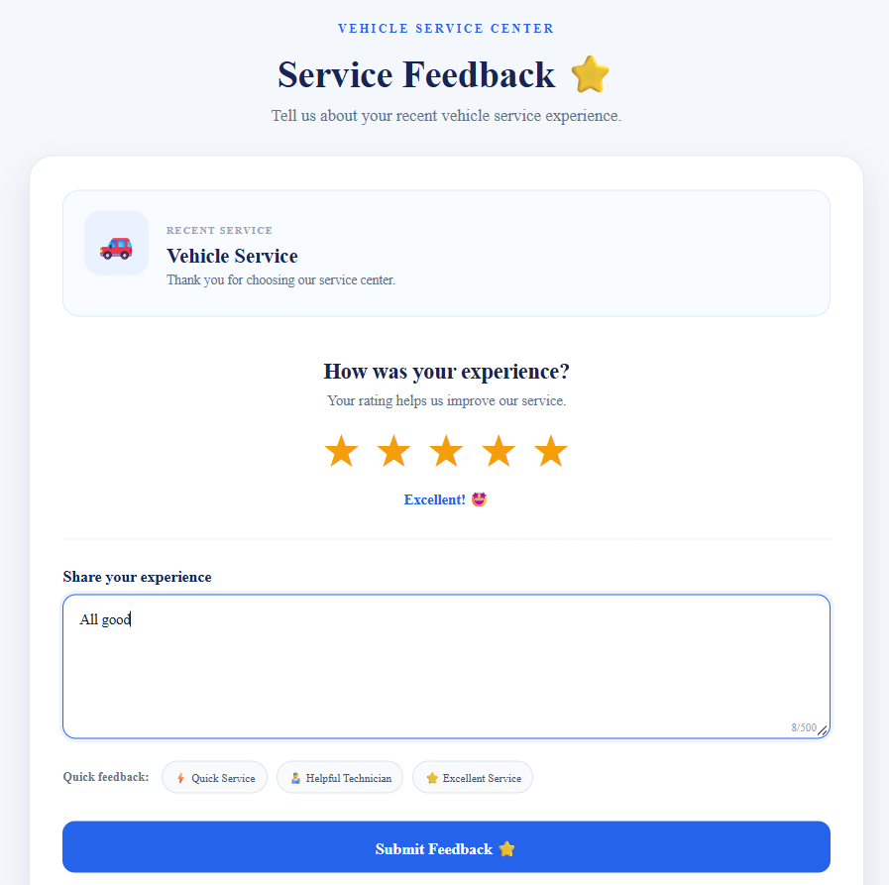

- Profile Page 